
Research Review Journals
Research Review International Journal of Multidisciplinary
ISSN: 2455:3085 (Online)
www.rrjournals.com

Consent to Publish & Transfer of Copyright

Under the Indian Copyright Law, the transfer of copyright from the author should be explicitly stated in writing to enable the publisher to publish and disseminate the author’s work to the fullest extent.

Title of Paper | From Philosophy to Practice: Reflected Values in Learners Shaped by Tagore’s  Educational Vision
Author(s) | 1ST Author | 2nd Author | 3rd Author | 4th Author | 5th Author
Name of Author | Dr. Vimal Singh
Designation | Assistant Professor
Affiliation | Department of Education, CSJM, University Kanpur UP

Corresponding Author’s Name: Dr. Vimal Singh Email: drvimalsingh@csjmu.ac.in

- The undersigned author or authors (Author) of the above article (Article) transfers and assigns exclusively to Research Review International Journal of Multidisciplinary all Author’s right, title and interest in the Article, including, without limitation, the copyright therein. These rights include without limitation mechanical, electronic and visual reproduction; electronic storage and retrieval; and all other forms of electronic publication or any other types of publication including all subsidiary rights.

- In return for said rights, Publisher grants to Author the following rights.

  - All proprietary rights relating to the Article, other than copyright, such as patent rights.
  - The right to use, after publication, part or the entire Article in subsequent works of Author, provided that written permission is granted by Publisher and that proper acknowledgement is made to the source and to the Publisher.
  - The right to make oral presentation of the material in any form.

- Any other use or reproduction of the work requires a fee and/or permission from Publisher.
- In the event that the Article is not accepted and published by Publisher, this agreement becomes null and void.
- Author warrants that the Article is original work and has not been published before in any form and that it does not infringe upon any copyright, contains no libelous or otherwise unlawful statements, and does not otherwise infringe on the rights of others, and that any necessary permission to quote from another source has been obtained. (In some journals, articles that have appeared in conference proceedings are acceptable; therefore, if this is the case, Author should annotate this agreement by including the date and name of the conference at the bottom.)
- The Author declares that any person named as co-author of the Contribution is aware of the fact and has agreed to being so named.

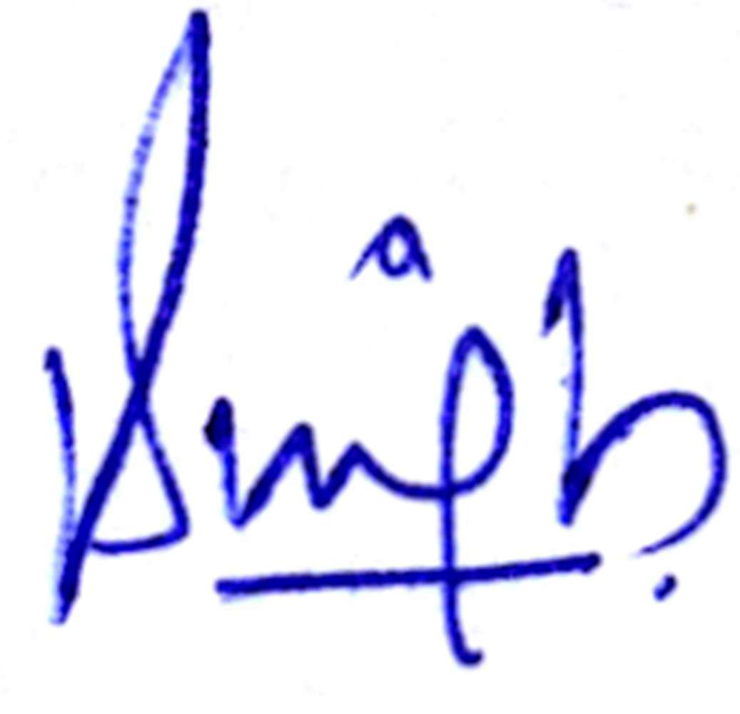
06.07.2026

____________________________________________ __________________________
Author’s Signature Date
(at least by the corresponding/main author)

